Spring Framework

1. Write a program to print “Hello World” using spring framework.
2. Write a program to demonstrate dependency injection via setter method.
3. Write a program to demonstrate dependency injection via Constructor.

Steps to Create Spring Legacy Project
Step 1 : Creating Spring Legacy Project.
1.1 : Open Eclipse. Go To File > New > Other.
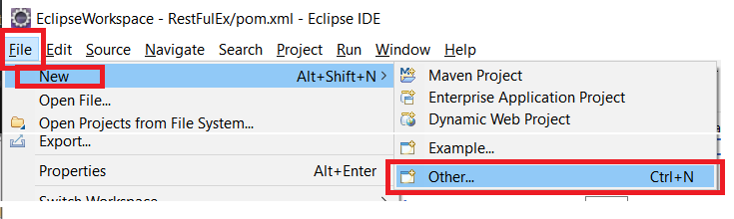

1.2 : Search for ‘spring’ and Select ‘Spring Legacy Project’. Then Click on Next.
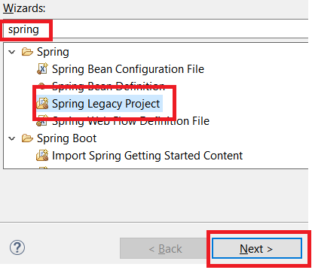
1.3 : ChooseProject Name of your wish, below there select Simple Java & simply Finish.
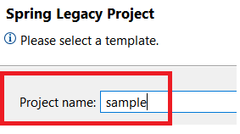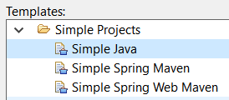
1.4 : If asked for Creating module-info.java file, click on Don’t Create.
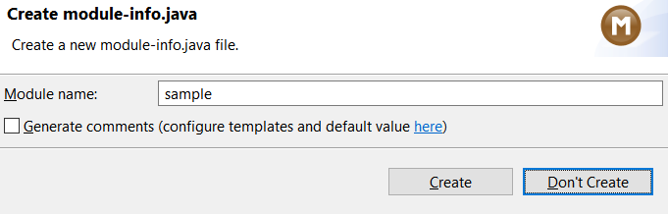

Step 2 : Adding the Spring Libraries.
2.1 : Right click on your Newly created Spring Legacy project, Choose Build Path > Configure Build Path.
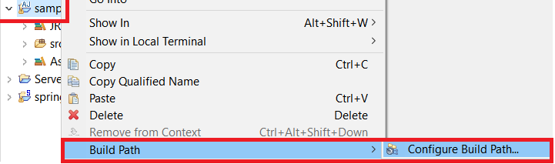
2.2 On Java Build Path wizard, Choose Classpath and then select Add External JARs.
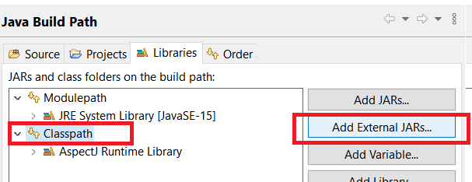
2.3 : Choose all the Spring Libraries you’ve downloaded, and click on OPEN. This will add all libraries to Classpath.
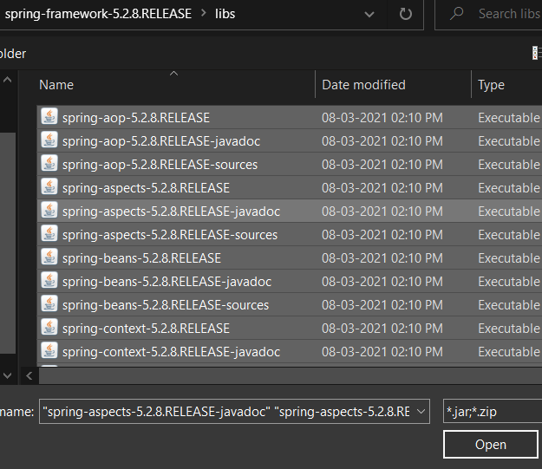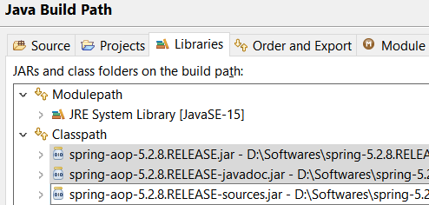
2.4 Finally click on Apply & Close, now you are ready to work with Spring Legacy Project.
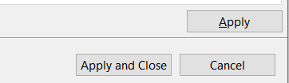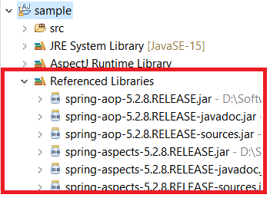

Problem Statement 1 : Write a program to print “Hello World” using spring framework.
Solution :

HelloWorld.java
package spring1;

publicclass HelloWorld {

String name;

public String getName() {
return name;
}

publicvoid setName(String name) {
this.name = name;
}

@Override
public String toString() {
return "Hello World, I'm " + name + ".";
}
}

appctx3.xml
<?xml version="1.0" encoding="UTF-8"?>
<beans xmlns="http://www.springframework.org/schema/beans"
xmlns:xsi="http://www.w3.org/2001/XMLSchema-instance"
xsi:schemaLocation="http://www.springframework.org/schema/beans http://www.springframework.org/schema/beans/spring-beans.xsd">

<bean id="hw" class="spring1.HelloWorld">
<property name="name" value="Vinit"/>
</bean>

</beans>

TestHelloWorld.java
package spring1;

import org.springframework.context.support.ClassPathXmlApplicationContext;

publicclass TestHelloWorld {

publicstaticvoid main(String[] args) {

ClassPathXmlApplicationContext app = new ClassPathXmlApplicationContext("appctx3.xml");
HelloWorld hw = (HelloWorld) app.getBean("hw");

System.out.println(hw.toString());

}

}

Output :
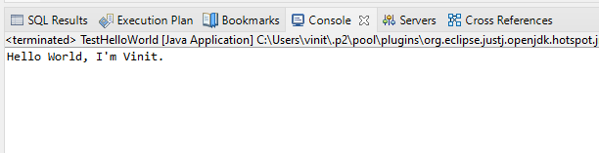
Problem Statement 2 : Write a program to demonstrate dependency injection via setter method.
Solution:
Account.java
package spring1;

publicclass Account {

int id;
String name;
int balance;

public Account(int id, String name, int balance) {
super();
this.id = id;
this.name = name;
this.balance = balance;
}
publicint getId() {
return id;
}
publicvoid setId(int id) {
this.id = id;
}
public String getName() {
return name;
}
publicvoid setName(String name) {
this.name = name;
}
publicint getBalance() {
return balance;
}
Public void setBalance(int balance) {
this.balance = balance;
}
@Override
public String toString() {
return "Account [id=" + id + ", name=" + name + ", balance=" + balance + "]";
}

}

appctx2.xml

<?xml version="1.0" encoding="UTF-8"?>
<beans xmlns="http://www.springframework.org/schema/beans"
xmlns:xsi="http://www.w3.org/2001/XMLSchema-instance"
xsi:schemaLocation="http://www.springframework.org/schema/beans http://www.springframework.org/schema/beans/spring-beans.xsd">

<bean id="Account" class="spring1.Account">

<constructor-arg name="id" value="1"></constructor-arg>
<constructor-arg name="name" value="vinit"></constructor-arg>
<constructor-arg name="balance" value="69000"></constructor-arg>

</bean>

</beans>

AccountTest.java

package spring1;

import org.springframework.context.ApplicationContext;
import org.springframework.context.support.ClassPathXmlApplicationContext;

public class Accounttest {

public static void main(String[] args) {

ApplicationContext con = new ClassPathXmlApplicationContext("appctx2.xml");
Account acc = (Account) con.getBean("Account");

System.out.println(acc.toString());

}
}

Output :
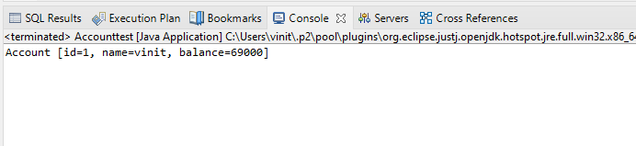
Problem Statement 3 : Write a program to demonstrate dependency injection via Constructor.
Solution:
Singer.java
package spring1;

publicclass Singer {
String name;
int age;
public String getName() {
return name;
}
publicvoid setName(String name) {
this.name = name;
}
publicint getAge() {
return age;
}
publicvoid setAge(int age) {
this.age = age;
}
void displayInfo()
{
System.out.println("Name:" +name+" Age:" +age);
}
}

appctx.xml

<?xml version="1.0" encoding="UTF-8"?>
<beans xmlns="http://www.springframework.org/schema/beans"
xmlns:xsi="http://www.w3.org/2001/XMLSchema-instance"
xsi:schemaLocation="http://www.springframework.org/schema/beans http://www.springframework.org/schema/beans/spring-beans.xsd">
<bean id="Singer" class="spring1.Singer">
<property name="name" value="vinit"></property>
<property name="age" value="21"></property>
</bean>

</beans>

SingerTest.java

package spring1;

import org.springframework.context.ApplicationContext;
import org.springframework.context.support.ClassPathXmlApplicationContext;

public class SingerTest {

private static ApplicationContext ctx;
public static void main(String[] args) {
// TODO Auto-generated method stub
ctx=new ClassPathXmlApplicationContext("appctx.xml");
Singer singer=(Singer)ctx.getBean("Singer");
singer.displayInfo();

}

}

Output :

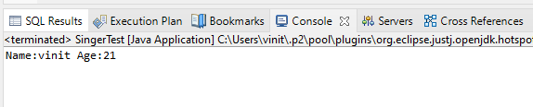
Assignment No 8
Aspect Oriented Programming

1. Write a program to demonstrate Spring AOP – before advice.
2. Write a program to demonstrate Spring AOP – after advice.
3. Write a program to demonstrate Spring AOP – around advice.
4. Write a program to demonstrate Spring AOP – after returning advice.
5. Write a program to demonstrate Spring AOP – after throwing advice.
6. Write a program to demonstrate Spring AOP – pointcuts.

Steps to Create an AOP Project

Step 1 : Creating AspectJ Project.
1.1 : Open Eclipse. Go To File > New > Other.

1.2 : Search for ‘aspect’ and Select ‘AspectJ Project’. Then Click on Next.
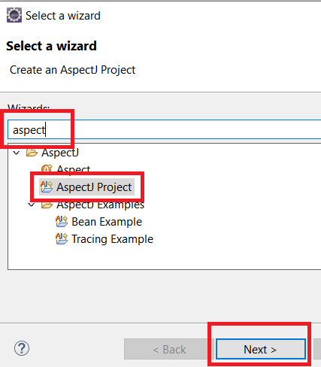

1.3 : Enter Project Name of your wish, and click on Finish.
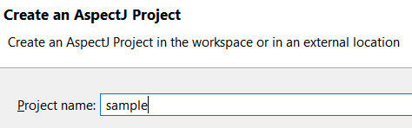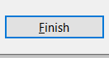

1.4 : If asked to create module-info.java file, select ‘Don’t Create’.
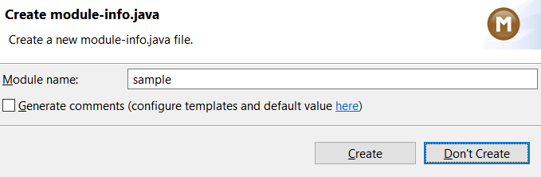

1.5 : Finally if you are asked to Open Java Perspective, just choose NO.
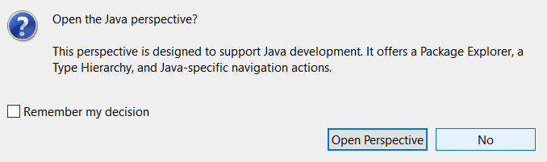
This creates your AspectJ project.

Step 2 : Adding the Spring Libraries.
2.1 : Right click on your Newly created AspectJ project, Choose Build Path > Configure Build Path.
2.2 On Java Build Path wizard, Choose Classpathand then select Add External JARs.
2.3 : Choose all the Spring Libraries you’ve downloaded, and click on OPEN. This will add all libraries to Classpath.
2.4 Finally click on Apply & Close, now you are ready to work with Aspects in Spring.
Problem Statement 1 : Write a program to demonstrate Spring AOP – before advice.
Solution :
beforeaop.java
package bvimit.edu;

import org.aspectj.lang.JoinPoint;
import org.aspectj.lang.annotation.Aspect;
import org.aspectj.lang.annotation.Before;
import org.aspectj.lang.annotation.Pointcut;

@Aspect
public class beforeaop {

@Pointcut("execution(int beforeoperation.*(..))")
public void p(){}

@Before("p()")
public void myadvice(JoinPoint jp)
{
System.out.println("before advice");
}
}

beforeoperation.java

package bvimit.edu;

publicclass beforeoperation {
publicvoid msg() {System.out.println("method 1");}
publicint m(){System.out.println("method 2 with return");return 2;}
publicint k(){System.out.println("method 3 with return");return 3;}
}
aopctx1.xml
<?xml version="1.0" encoding="UTF-8"?>
<beans xmlns="http://www.springframework.org/schema/beans"
xmlns:xsi="http://www.w3.org/2001/XMLSchema-instance"
xsi:schemaLocation="http://www.springframework.org/schema/beans http://www.springframework.org/schema/beans/spring-beans.xsd">

<bean id="opBean" class="bvimit.edu.beforeoperation"></bean>

<bean id="trackMyBean" class="bvimit.edu.beforeaop"></bean>

<bean class="org.springframework.aop.aspectj.annotation.AnnotationAwareAspectJAutoProxyCreator"></bean>

</beans>
beforetest.java
package bvimit.edu;

import org.springframework.context.ApplicationContext;
import org.springframework.context.support.ClassPathXmlApplicationContext;

public class beforetest {

public static void main(String[] args) {
ApplicationContext context = new ClassPathXmlApplicationContext("aopctx1.xml");
beforeoperation e = (beforeoperation) context.getBean("opBean");
System.out.println("calling m1......");
e.msg();
System.out.println("calling m2......");
e.m();
System.out.println("calling m3......");
e.k();

}

}

Output :

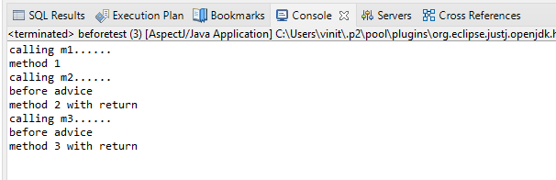
Problem Statement 2 : Write a program to demonstrate Spring AOP – after advice.
Solution :
Afteraopdata.java
package bvimit.edu;

import org.aspectj.lang.JoinPoint;
import org.aspectj.lang.annotation.After;
import org.aspectj.lang.annotation.Aspect;
import org.aspectj.lang.annotation.Pointcut;

@Aspect
public class afteraopdata {

@Pointcut("execution(int afteroperation.*(..))")
public void p(){}

@After("p()")
public void myadvice(JoinPoint jp)
{
System.out.println("after advice");
}
}

afteroperation.java

package bvimit.edu;

publicclass afteroperation {
publicvoid msg() {System.out.println("method 1");}
publicint m(){System.out.println("method 2 with return");return 2;}
publicint k(){System.out.println("method 3 with return");return 3;}
}
aopctx.xml
<?xml version="1.0" encoding="UTF-8"?>
<beans xmlns="http://www.springframework.org/schema/beans"
xmlns:xsi="http://www.w3.org/2001/XMLSchema-instance"
xsi:schemaLocation="http://www.springframework.org/schema/beans http://www.springframework.org/schema/beans/spring-beans.xsd">

<bean id="opBean" class="bvimit.edu.afteroperation"></bean>

<bean id="trackMyBean" class="bvimit.edu.afteraopdata"></bean>

<bean class="org.springframework.aop.aspectj.annotation.AnnotationAwareAspectJAutoProxyCreator"></bean>
</beans>
aftertest.java
package bvimit.edu;

import org.springframework.context.ApplicationContext;
import org.springframework.context.support.ClassPathXmlApplicationContext;

public class aftertest {

public static void main(String[] args) {
ApplicationContext context = new ClassPathXmlApplicationContext("aopctx.xml");
afteroperation e = (afteroperation) context.getBean("opBean");
System.out.println("calling m1......");
e.msg();
System.out.println("calling m2......");
e.m();
System.out.println("calling m3......");
e.k();

}

}

Output :

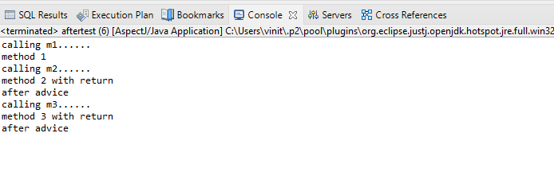

Problem Statement 3 : Write a program to demonstrate Spring AOP – around advice.
Solution :
Bankaopdata.java

package bvimit.edu;

import org.aspectj.lang.ProceedingJoinPoint;
import org.aspectj.lang.annotation.Around;
import org.aspectj.lang.annotation.Aspect;
import org.aspectj.lang.annotation.Pointcut;

@Aspect
public class Bankaopdata {

@Pointcut("execution(* Bank.*(..))")
public void a() {}

@Around("a()")
public Object myadvice(ProceedingJoinPoint p)throws Throwable
{
System.out.println("Around concern Before calling actual method");
Object obj=p.proceed();
System.out.println("Around Concern After calling actual method");
return obj;
}
}

Bank.java
package bvimit.edu;

publicclass Bank {
publicvoid welcome() {System.out.println("welcome to bank");}
publicint icici() {System.out.println("icici bank interest rate");return 7;}
publicint pnb() {System.out.println("pnb bank interest rate");return 6;}

}

Bankaopdata.xml

<?xml version="1.0" encoding="UTF-8"?>
<beans xmlns="http://www.springframework.org/schema/beans"
xmlns:xsi="http://www.w3.org/2001/XMLSchema-instance"
xsi:schemaLocation="http://www.springframework.org/schema/beans http://www.springframework.org/schema/beans/spring-beans.xsd">

<bean id="opBean" class="bvimit.edu.Bank"></bean>
<bean id="trackMyBean" class="bvimit.edu.Bankaopdata"></bean>

<bean class="org.springframework.aop.aspectj.annotation.AnnotationAwareAspectJAutoProxyCreator"></bean>
</beans>

Banktest.java
package bvimit.edu;

import org.springframework.context.ApplicationContext;
import org.springframework.context.support.ClassPathXmlApplicationContext;

publicclass Banktest {

privatestatic ApplicationContext context;

publicstaticvoid main(String[] args) {
context = new ClassPathXmlApplicationContext("Bankaopdata.xml");

Bank e =(Bank) context.getBean("opBean");
System.out.println("Calling welcome method...");
e.welcome();
System.out.println("Calling icici method...");
e.icici();
System.out.println("Calling pnb method...");
e.pnb();
}

}

Output :
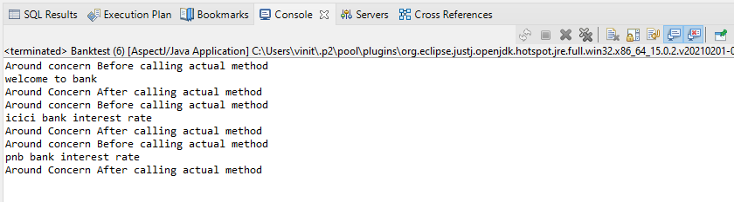
Problem Statement 4 : Write a program to demonstrate Spring AOP – after returning advice.
Solution :
Bankaopdata.java
package bvimit.edu;

import org.aspectj.lang.JoinPoint;
importorg.aspectj.lang.ProceedingJoinPoint;
import org.aspectj.lang.annotation.AfterReturning;
importorg.aspectj.lang.annotation.Around;
import org.aspectj.lang.annotation.Aspect;
importorg.aspectj.lang.annotation.Pointcut;

@Aspect
publicclass Bankaopdata {

@AfterReturning(
pointcut ="execution(* Bank.*(..))",
returning="result")
publicvoid myadvice(JoinPoint jp,Object result)
{
System.out.println("AfterReturning concern");
System.out.println("Result in advice" +result);
}
}

Bank.java
package bvimit.edu;

publicclass Bank {
publicvoid welcome() {System.out.println("welcome to bank");}
publicint icici() {System.out.println("icici bank interest rate");return 7;}
publicint pnb() {System.out.println("pnb bank interest rate");return 6;}

}

Bankaopdata.xml
<?xml version="1.0" encoding="UTF-8"?>
<beans xmlns="http://www.springframework.org/schema/beans"
xmlns:xsi="http://www.w3.org/2001/XMLSchema-instance"
xsi:schemaLocation="http://www.springframework.org/schema/beans http://www.springframework.org/schema/beans/spring-beans.xsd">

<bean id="opBean" class="bvimit.edu.Bank"></bean>
<bean id="trackMyBean" class="bvimit.edu.Bankaopdata"></bean>

<bean class="org.springframework.aop.aspectj.annotation.AnnotationAwareAspectJAutoProxyCreator"></bean>
</beans>

Banktest.java
package bvimit.edu;

import org.springframework.context.ApplicationContext;
import org.springframework.context.support.ClassPathXmlApplicationContext;

publicclass Banktest {

privatestatic ApplicationContext context;

publicstaticvoid main(String[] args) {
context = new ClassPathXmlApplicationContext("Bankaopdata.xml");

Bank e =(Bank) context.getBean("opBean");
//System.out.println("Calling welcome method...");
e.welcome();
//System.out.println("Calling icici method...");
e.icici();
//System.out.println("Calling pnb method...");
e.pnb();
}

}

Output :
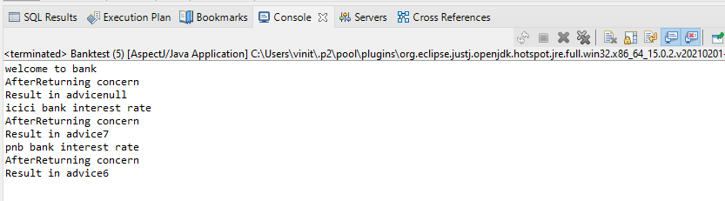
Problem Statement 5 : Write a program to demonstrate Spring AOP – after throwing advice.
Solution :
Operationaop_at.java
package bvimit.edu;
import org.aspectj.lang.JoinPoint;
import org.aspectj.lang.annotation.AfterThrowing;
import org.aspectj.lang.annotation.Aspect;

@Aspect
publicclass Operationaop_at {
@AfterThrowing(
pointcut = "execution(* Operation_at.*(..))", throwing = "error")
publicvoid myadvice(JoinPoint jp, Throwable error)
{
System.out.println("AfterThrowing concern");
System.out.println("Exception is: "+error);
System.out.println("end of after throwing advice....");
}
}

Operation_at.java
package bvimit.edu;
publicclass Operation_at {

publicvoid validate(int att)throws Exception{
if(att<75) {
thrownew ArithmeticException("Not eligible for exam");
}
else {
System.out.println("Eligible for exam");
}
}
}

validctx.xml
<?xml version="1.0" encoding="UTF-8"?>
<beans xmlns="http://www.springframework.org/schema/beans"
xmlns:xsi="http://www.w3.org/2001/XMLSchema-instance"
xsi:schemaLocation="http://www.springframework.org/schema/beans http://www.springframework.org/schema/beans/spring-beans.xsd">

<bean id="opBean" class="bvimit.edu.Operation_at"></bean>

<bean id="trackMyBean" class="bvimit.edu.Operationaop_at"></bean>

<bean class="org.springframework.aop.aspectj.annotation.AnnotationAwareAspectJAutoProxyCreator"></bean></beans>

TestValidation.java
package bvimit.edu;
import org.springframework.context.ApplicationContext;
import org.springframework.context.support.ClassPathXmlApplicationContext;

public class OperationTest_at {
private static ApplicationContext context;
public static void main(String[] args) {
ApplicationContext context = new ClassPathXmlApplicationContext("validctx.xml");
Operation_at op = (Operation_at) context.getBean("opBean");
System.out.println("calling validate....");
try {
op.validate(85);
}catch(Exception e){System.out.println(e);}

System.out.println("calling validate again....");

try {
op.validate(25);
}catch(Exception e){System.out.println(e);}
}
}

Output :
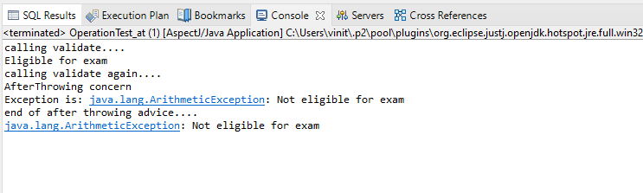

Problem Statements 6:Write a program to demonstrate Spring AOP –pointcuts.
Solution:
Operation_pc.java
package bvimit.edu;
publicclass Operation_pc {

publicvoid msg() {System.out.println("method 1");}
publicint m() {System.out.println("method 2 with return");return 2;}
publicint k() {System.out.println("method 3 with return");return 3;}
}

Aopdata_pc.java
package bvimit.edu;
import org.aspectj.lang.JoinPoint;
import org.aspectj.lang.annotation.After;
import org.aspectj.lang.annotation.Pointcut;
import org.aspectj.lang.annotation.Aspect;
import org.aspectj.lang.annotation.Before;
@Aspect
public class Aopdata_pc {

@Pointcut("execution(int Operation.*(..))")
public void p(){}

@After("p()")
public void myadvice(JoinPoint jp)
{
System.out.println("After advice");
}
@Pointcut("execution(* Operation.*(..))")
public void i(){}

@Before("i()")
public void myadvice1(JoinPoint jp)
{
System.out.println("Before advice");
}
}

Test_pc.java
package bvimit.edu;
import org.springframework.context.ApplicationContext;
import org.springframework.context.support.ClassPathXmlApplicationContext;

public class Test_pc {
public static void main(String[] args) {

ApplicationContext context = new ClassPathXmlApplicationContext("aopctx_pc.xml");
Operation_pc e=(Operation_pc)context.getBean("opBean");
System.out.println("calling m1...");
e.msg();
System.out.println("calling m2...");
e.m();
System.out.println("calling m3...");
e.k();
}
}

aopctx_pc.xml
<?xml version="1.0" encoding="UTF-8"?>
<beans xmlns="http://www.springframework.org/schema/beans"
xmlns:xsi="http://www.w3.org/2001/XMLSchema-instance"
xsi:schemaLocation="http://www.springframework.org/schema/beans http://www.springframework.org/schema/beans/spring-beans.xsd">

<bean id="opBean" class="bvimit.edu.Operation_pc"></bean>

<bean id="trackMyBean" class="bvimit.edu.Aopdata_pc"></bean>

<bean class="org.springframework.aop.aspectj.annotation.AnnotationAwareAspectJAutoProxyCreator"></bean>

</beans>

Output:

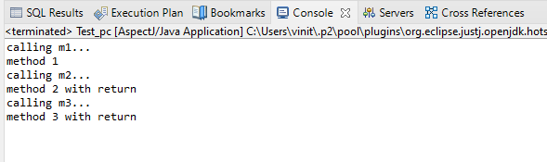

Assignment No 9
Spring JDBC

1. Write a program to insert, update and delete records from the given table.
2. Write a program to demonstrate PreparedStatement in Spring JdbcTemplate.
3. Write a program in Spring JDBC to demonstrate ResultSetExtractor Interface.
4. Write a program to demonstrate RowMapper interface to fetch the records from the database.

Steps to Create Spring Legacy Project
Step 1 : Creating Spring Legacy Project.
1.1 : Open Eclipse. Go To File > New > Other.

1.2 : Search for ‘spring’ and Select ‘Spring Legacy Project’. Then Click on Next.
1.3 : ChooseProject Name of your wish, below there select Simple Java& simply Finish.
1.4 : If asked for Creating module-info.java file, click on Don’t Create.

Step 2 : Adding the Spring Libraries.
2.1 : Right click on your Newly created Spring Legacy project, Choose Build Path > Configure Build Path.
2.2 On Java Build Path wizard, Choose Classpath and then select Add External JARs.
2.3 : Choose all the Spring Libraries you’ve downloaded, and click on OPEN. This will add all libraries to Classpath.
2.4 Finally click on Apply & Close, now you are ready to work with Spring Legacy Project.
Problem Statement 1 : Write a program to insert, update and delete records from the given table.
Solution :
Movie1.java
package org.me;

publicclass Movie1 {

int mid;
String title;
String actor;
public Movie1(int mid, String title, String actor) {
super();
this.mid = mid;
this.title = title;
this.actor = actor;
}
public Movie1() {
super();
// TODO Auto-generated constructor stub
}
publicint getMid() {
return mid;
}
publicvoid setMid(int mid) {
this.mid = mid;
}
public String getTitle() {
return title;
}
publicvoid setTitle(String title) {
this.title = title;
}
public String getActor() {
return actor;
}
publicvoid setActor(String actor) {
this.actor = actor;
}

}

MovieDAO.java
package org.me;

import org.springframework.jdbc.core.*;
publicclass MovieDAO {
JdbcTemplate jdbcTemplate;

publicvoid setJdbcTemplate(JdbcTemplate jdbcTemplate) {
this.jdbcTemplate = jdbcTemplate;
}
publicint insMovie(Movie1 m1)
{
String insSql="insert into mymovies1 values("+m1.getMid()+",'"+m1.getTitle()+"','"+m1.getActor()+"')";

return jdbcTemplate.update(insSql);
}

publicint updateMovie(Movie1 m1){
String query="update mymovies1 set title='"+m1.getTitle()+"',actor='"+m1.getActor()+"' where mid='"+m1.getMid()+"' ";
return jdbcTemplate.update(query);
}

publicint deleteMovie(Movie1 m1){
String query="delete from mymovies1 where mid='"+m1.getMid()+"' ";
return jdbcTemplate.update(query);
}
}

appctx.xml
<?xml version="1.0" encoding="UTF-8"?>
<beans xmlns="http://www.springframework.org/schema/beans"
xmlns:xsi="http://www.w3.org/2001/XMLSchema-instance"
xsi:schemaLocation="http://www.springframework.org/schema/beans http://www.springframework.org/schema/beans/spring-beans.xsd">

<bean id="ds" class="org.springframework.jdbc.datasource.DriverManagerDataSource">
<property name="driverClassName"value="org.postgresql.Driver" />
<property name="url" value="jdbc:postgresql://localhost:5432/postgres" />
<property name="username" value="postgres" />
<property name="password" value="admin" />
</bean>

<bean id="jdbcTemplate" class="org.springframework.jdbc.core.JdbcTemplate">
<property name="dataSource" ref="ds"></property>
</bean>

<bean id="mymovie" class="org.me.MovieDAO">
<property name="jdbcTemplate" ref="jdbcTemplate"></property>
</bean></beans>

MovieTest.java
package org.me;

import org.springframework.context.ApplicationContext;
import org.springframework.context.support.ClassPathXmlApplicationContext;

public class MovieTest {
private static ApplicationContext appCon;

public static void main(String[] args) {
// TODO Auto-generated method stub

appCon = new ClassPathXmlApplicationContext("appctx.xml");
MovieDAO m1=(MovieDAO)appCon.getBean("mymovie");

//insert query
Movie1 t1=new Movie1(10,"Mirzapur","P");
System.out.println(m1.insMovie(t1));

//update query

//int status=m1.updateMovie(new Movie1(10,"war","hritik"));
// System.out.println(status);

//delete

// Movie1 t2=new Movie1();
//t2.setMid(5);
//int status=m1.deleteMovie(t2);
// System.out.println(status);

}

}

Output :

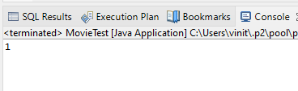

Database :
CREATE TABLE mymovies1
(
mid int,
title varchar(50),
actor varchar(50),
PRIMARY KEY (mid)
);
Final Table After Execution :
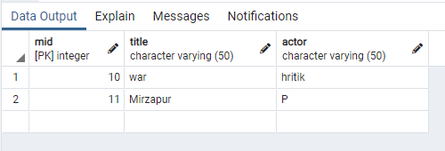
Problem Statement 2 : Write a program to demonstrate PreparedStatement in Spring JdbcTemplate.
Solution :
Movie1.java
package org.me;

public class Movie1 {

int mid;
String title;
String actor;
public Movie1(int mid, String title, String actor) {
super();
this.mid = mid;
this.title = title;
this.actor = actor;
}
public Movie1() {
super();
}
public int getMid() {
return mid;
}
public void setMid(int mid) {
this.mid = mid;
}
public String getTitle() {
return title;
}
public void setTitle(String title) {
this.title = title;
}
public String getActor() {
return actor;
}
public void setActor(String actor) {
this.actor = actor;
}

}

MovieDAO1.java
package org.me;
import java.sql.PreparedStatement;
import java.sql.SQLException;

import org.springframework.dao.DataAccessException;
import org.springframework.jdbc.core.JdbcTemplate;
import org.springframework.jdbc.core.PreparedStatementCallback;
public class MovieDAO1 {
JdbcTemplate jdbcTemplate;

public void setJdbcTemplate(JdbcTemplate jdbcTemplate) {
this.jdbcTemplate = jdbcTemplate;
}
public Boolean saveMovieByPreparedStatement(final Movie1 e){
String query="insert into movies values(?,?,?)";
return jdbcTemplate.execute(query,new PreparedStatementCallback<Boolean>(){
@Override
public Boolean doInPreparedStatement(PreparedStatement ps)
throws SQLException, DataAccessException {
ps.setInt(1,e.getMid());
ps.setString(2,e.getTitle());
ps.setString(3,e.getActor());
return ps.execute();
}
});
}
}

appctx1.java
<?xml version="1.0" encoding="UTF-8"?>
<beans xmlns="http://www.springframework.org/schema/beans"
xmlns:xsi="http://www.w3.org/2001/XMLSchema-instance"
xsi:schemaLocation="http://www.springframework.org/schema/beans http://www.springframework.org/schema/beans/spring-beans.xsd">

<bean id="ds" class="org.springframework.jdbc.datasource.DriverManagerDataSource">
<property name="driverClassName" value="org.postgresql.Driver" />
<property name="url" value="jdbc:postgresql://localhost:5432/postgres" />
<property name="username" value="postgres" />
<property name="password" value="pass" />
</bean>

<bean id="jdbcTemplate" class="org.springframework.jdbc.core.JdbcTemplate">
<property name="dataSource" ref="ds"></property>
</bean>

<bean id="mymovie" class="org.me.MovieDAO1">
<property name="jdbcTemplate" ref="jdbcTemplate"></property>
</bean>
</beans>

MovieTest1.java
package org.me;
import org.springframework.context.ApplicationContext;
import org.springframework.context.support.ClassPathXmlApplicationContext;
public class MovieTest1 {

private static ApplicationContext appCon;
public static void main(String[] args) {
// TODO Auto-generated method stub
appCon = new ClassPathXmlApplicationContext("appctx1.xml");
MovieDAO1 m1=(MovieDAO1)appCon.getBean("mymovie");
m1.saveMovieByPreparedStatement(new Movie1(5,"Bhaijaan","Slemon"));
}
}

Output :
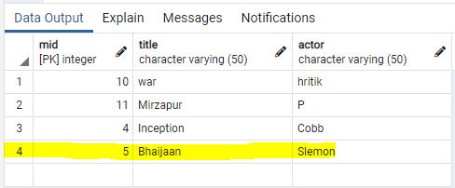
Problem Statement 3 : Write a program in Spring JDBC to demonstrate ResultSetExtractor Interface.
Solution :
Movie2.java
package org.me;

public class Movie2 {

int mid;
String title;
String actor;
public int getMid() {
return mid;
}
public void setMid(int mid) {
this.mid = mid;
}
public String getTitle() {
return title;
}
public void setTitle(String title) {
this.title = title;
}
public String getActor() {
return actor;
}
public void setActor(String actor) {
this.actor = actor;
}
public String toString(){
return mid+" "+title+" "+actor;

}
}

MovieDAO2.java
package org.me;
import java.sql.ResultSet;
import java.sql.SQLException;
import java.util.ArrayList;
import java.util.List;
import org.springframework.dao.DataAccessException;
import org.springframework.jdbc.core.JdbcTemplate;
import org.springframework.jdbc.core.ResultSetExtractor;
public class MovieDAO2 {
JdbcTemplate jdbcTemplate;

public void setJdbcTemplate(JdbcTemplate jdbcTemplate) {
this.jdbcTemplate = jdbcTemplate;
}
public List<Movie2> getAllMovie(){
return jdbcTemplate.query("select * from mymovies1",new ResultSetExtractor<List<Movie2>>(){
@Override
public List<Movie2> extractData(ResultSet rs) throws SQLException,
DataAccessException {

List<Movie2> list=new ArrayList<Movie2>();
while(rs.next()){
Movie2 e=new Movie2();
e.setMid(rs.getInt(1));
e.setTitle(rs.getString(2));
e.setActor(rs.getString(3));
list.add(e);
}
return list;
}
});
}
}

appctx2.java
<?xml version="1.0" encoding="UTF-8"?>
<beans xmlns="http://www.springframework.org/schema/beans"
xmlns:xsi="http://www.w3.org/2001/XMLSchema-instance"
xsi:schemaLocation="http://www.springframework.org/schema/beans http://www.springframework.org/schema/beans/spring-beans.xsd">

<bean id="ds" class="org.springframework.jdbc.datasource.DriverManagerDataSource">
<property name="driverClassName" value="org.postgresql.Driver" />
<property name="url" value="jdbc:postgresql://localhost:5432/postgres" />
<property name="username" value="postgres" />
<property name="password" value="password" />
</bean>

<bean id="jdbcTemplate" class="org.springframework.jdbc.core.JdbcTemplate">
<property name="dataSource" ref="ds"></property>
</bean>

<bean id="mymovie" class="org.me.MovieDAO2">
<property name="jdbcTemplate" ref="jdbcTemplate"></property>
</bean>
</beans>

MovieTest2.java
package org.me;
import java.util.List;
import org.springframework.context.ApplicationContext;
import org.springframework.context.support.ClassPathXmlApplicationContext;
public class MovieTest2 {
private static ApplicationContext appCon;
public static void main(String[] args) {
appCon = new ClassPathXmlApplicationContext("appctx2.xml");
MovieDAO2 m1=(MovieDAO2)appCon.getBean("mymovie");
List<Movie2> list=m1.getAllMovie();

for(Movie2 e:list)
System.out.println(e);
}
}

Output :
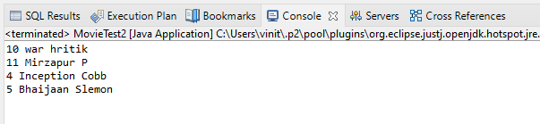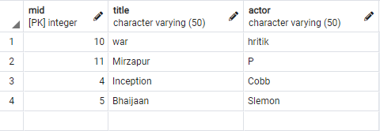

Problem Statement 4 :Write a program to demonstrate RowMapper interface to fetch the records from the database.
Solution :
Movie3.java
package org.me;

public class Movie3 {

int mid;
String title;
String actor;
public Movie3(int mid, String title, String actor) {
super();
this.mid = mid;
this.title = title;
this.actor = actor;
}

public Movie3() {
super();
// TODO Auto-generated constructor stub
}
public int getMid() {
return mid;
}
public void setMid(int mid) {
this.mid = mid;
}
public String getTitle() {
return title;
}
public void setTitle(String title) {
this.title = title;
}
public String getActor() {
return actor;
}
public void setActor(String actor) {
this.actor = actor;
}
}

MovieDAO3.java
package org.me;

import java.sql.ResultSet;
import java.sql.SQLException;
import java.util.List;

import org.springframework.jdbc.core.JdbcTemplate;
import org.springframework.jdbc.core.RowMapper;
public class MovieDAO3 {
JdbcTemplate jdbcTemplate;
public void setJdbcTemplate(JdbcTemplate jdbcTemplate) {
this.jdbcTemplate = jdbcTemplate;
}
public List<Movie2> getAllEmployeesRowMapper(){
return jdbcTemplate.query("select * from mymovies1",new RowMapper<Movie2>(){
@Override
public Movie2 mapRow(ResultSet rs, int rownumber) throws SQLException {
Movie2 e=new Movie2();
e.setMid(rs.getInt(1));
e.setTitle(rs.getString(2));
e.setActor(rs.getString(3));
return e;
}
});
}
}

appxtx3.xml
<?xml version="1.0" encoding="UTF-8"?>
<beans xmlns="http://www.springframework.org/schema/beans"
xmlns:xsi="http://www.w3.org/2001/XMLSchema-instance"
xsi:schemaLocation="http://www.springframework.org/schema/beans http://www.springframework.org/schema/beans/spring-beans.xsd">

<bean id="ds" class="org.springframework.jdbc.datasource.DriverManagerDataSource">
<property name="driverClassName" value="org.postgresql.Driver" />
<property name="url" value="jdbc:postgresql://localhost:5432/postgres" />
<property name="username" value="postgres" />
<property name="password" value="password" />
</bean>

<bean id="jdbcTemplate" class="org.springframework.jdbc.core.JdbcTemplate">
<property name="dataSource" ref="ds"></property>
</bean>

<bean id="mymovie" class="org.me.MovieDAO3">
<property name="jdbcTemplate" ref="jdbcTemplate"></property>
</bean>
</beans>

MovieTest3.java
package org.me;

import java.util.List;
import org.springframework.context.ApplicationContext;
import org.springframework.context.support.ClassPathXmlApplicationContext;
public class MovieTest3 {
private static ApplicationContext appCon;
public static void main(String[] args) {
appCon = new ClassPathXmlApplicationContext("appctx3.xml");
MovieDAO3 m1=(MovieDAO3)appCon.getBean("mymovie");
List<Movie2> list=m1.getAllEmployeesRowMapper();

for(Movie2 e:list)
System.out.println(e);
}
}

Output :

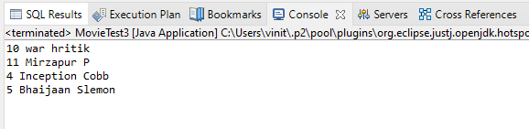

Assignment No 10
Spring Boot and RESTful Web Services

1. Write a program to create a simple Spring Boot application that prints a message.
2. Write a program to demonstrate RESTful Web Services with spring boot

Steps to Create a Spring Boot Project
Note : Make sure you have installed the Spring Plugin in Eclipse Itself.
Step 1 :
1.1 : Open Eclipse. Go To File > New > Other.
1.2 : Search for ‘Spring’ and Select ‘Spring Starter Project’. Then Click on Next.
On Next Wizard, Choose your Project Name, and other parameters such as Group ID, Artifact ID. Then Choose Next.
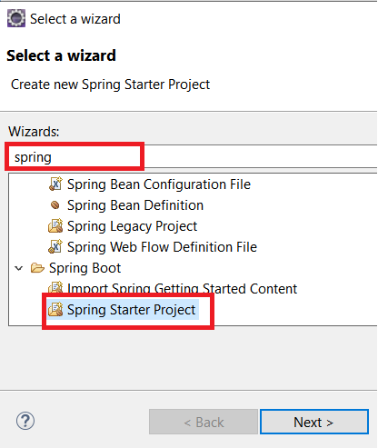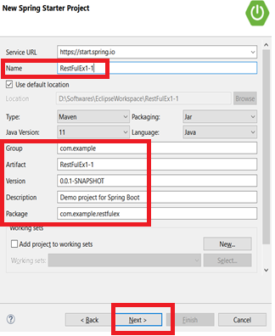
1.3 On next wizards, just click on “Finish”, once it is available.
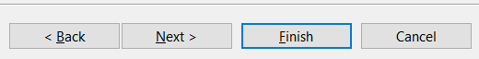

Step 2 : Go to https://start.spring.io/
Select All the Options specific to your Machine and Java Version.
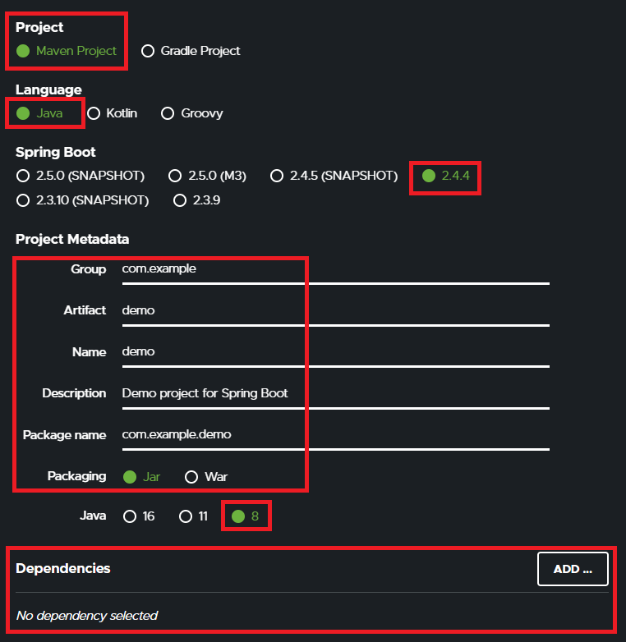

Selection of Dependencies is to be done as per Project Requirement :
For Ex. Lets add Spring Web Dependeny.
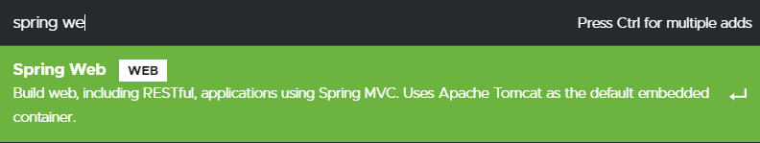

Click On Generate, a zip file will be downloaded.
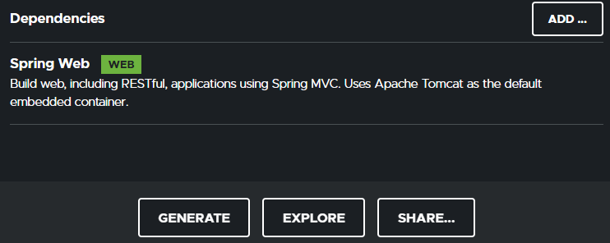


Unzip the downloaded zip file and open the pom.xml file inside the demo folder.
Copy the Contents of the pom.xml file & paste it in the pom.xml file of our created project from step 1.
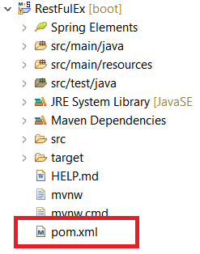
Save the file, an automatic download process will start, wait till its completed.
Now you are good to go and develop Spring Boot Applications.
Problem Statement 1 : Write a program to create a simple Spring Boot application that prints a message.
Solution :
BoothelloApplication.java
package com.example.demo;

import org.springframework.boot.SpringApplication;
import org.springframework.boot.autoconfigure.SpringBootApplication;

@SpringBootApplication
public class BoothelloApplication {

public static void main(String[] args) {
SpringApplication.run(BoothelloApplication.class, args);
}

}

HelloWorldController.java

package com.example.demo;

import org.springframework.web.bind.annotation.RequestMapping;
import org.springframework.web.bind.annotation.RestController;

@RestController
public class HelloWorldController {
@RequestMapping("/")
public String hello()
{
return "Vinit is here !";
}
}

Output :

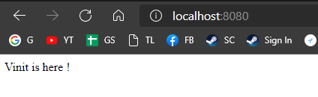
Problem Statement 2 : Write a program to demonstrate RESTful Web Services with spring boot
Solution :
HelloWorldBean.java
package com.example.demo;

publicclass HelloWorldBean {

public String message;
//constructor of HelloWorldBean
public HelloWorldBean(String message)
{
this.message=message;
}
//generating getters and setters
public String getMessage()
{
return message;
}
publicvoid setMessage(String message)
{
this.message = message;
}
@Override
//generate toString
public String toString()
{
return String.format ("HelloWorldBean [message=%s]", message);
}
}

HelloWorldController.java
package com.example.demo;

import org.springframework.web.bind.annotation.GetMapping;
import org.springframework.web.bind.annotation.RestController;
//Controller
@RestController
public class HelloWorldController
{
//using get method and hello-world as URI
@GetMapping(path="/hello-world")
public String helloWorld()
{
return "Vinit is here!";
}
@GetMapping(path="/hello-world-bean")
public HelloWorldBean helloWorldBean()
{
return new HelloWorldBean("Kaise ho? xD"); //constructor of HelloWorldBean } }
RestfulwebserviceApplication.java
package com.example.demo;

import org.springframework.boot.SpringApplication;
import org.springframework.boot.autoconfigure.SpringBootApplication;

@SpringBootApplication
public class RestfulwebserviceApplication {

public static void main(String[] args) {
SpringApplication.run(RestfulwebserviceApplication.class, args);
}

}

Output :

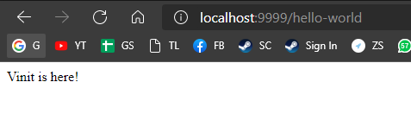
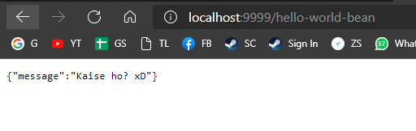

Testing API with PostMan.
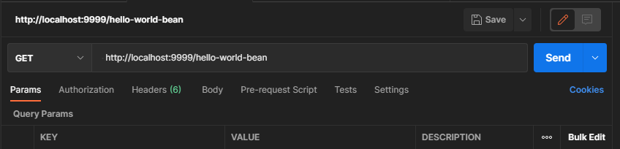
EndPoint : http://localhost:9999/hello-world-bean

